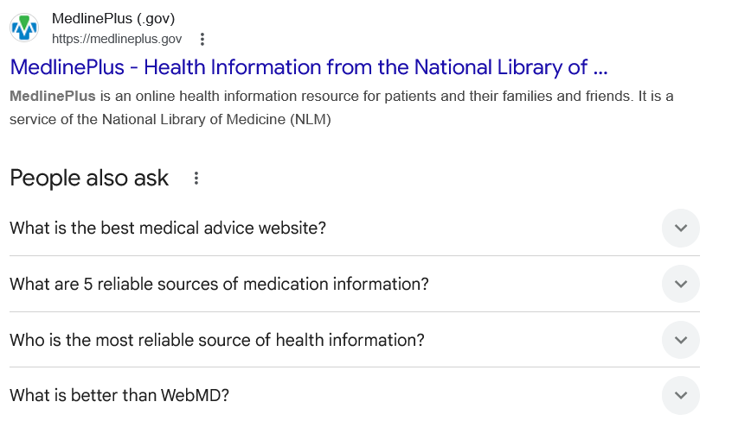
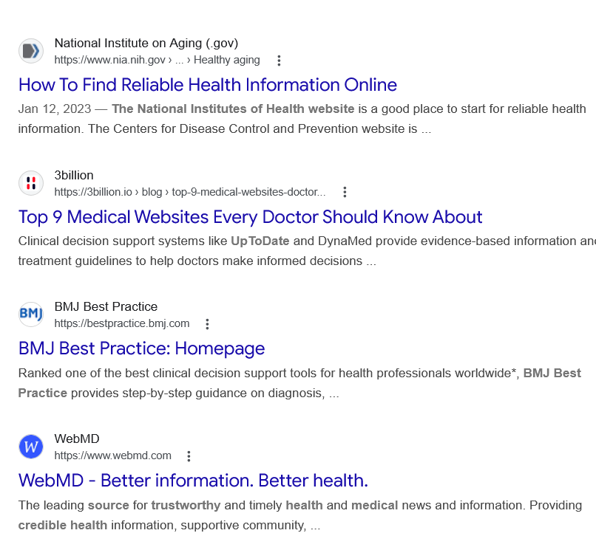
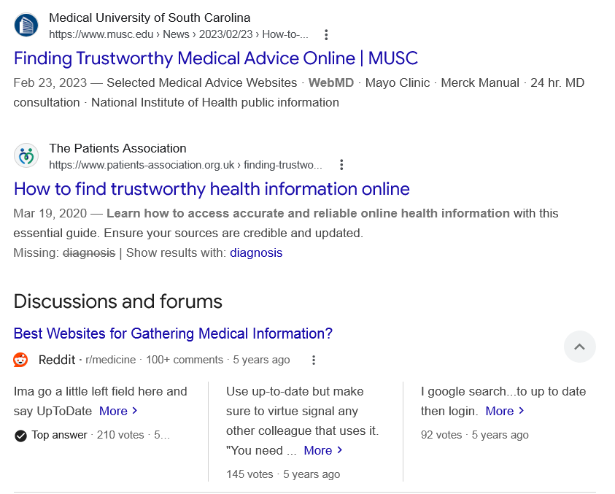
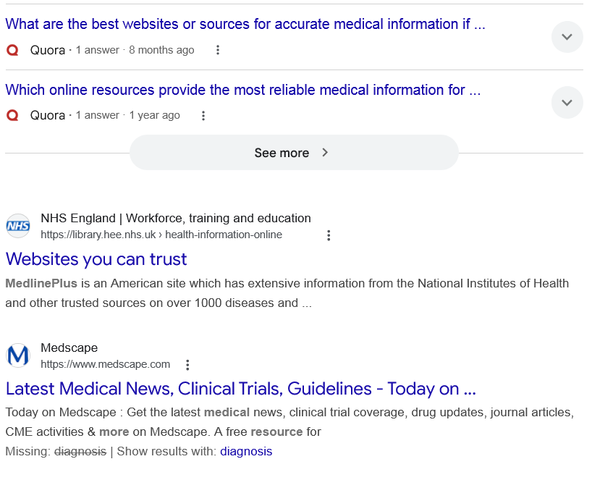
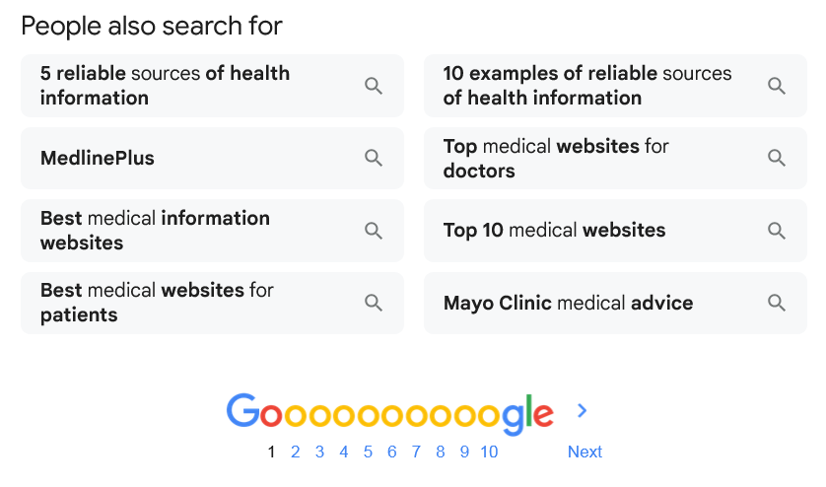

Web results

MedlinePlus - Health Information from the National Library of ...

MedlinePlus (.gov)
https://medlineplus.gov

MedlinePlus (.gov)
https://medlineplus.gov
MedlinePlus is an online health information resource for patients and their families and friends. It is a service of the National Library of Medicine (NLM)
People also ask
What is the best medical advice website?
MedlinePlus.gov is a website from the NIH National Library of Medicine that has dependable consumer health information on more than 1,000 health-related topics.Jan 12, 2023

How To Find Reliable Health Information Online

National Institute on Aging (.gov)
https://www.nia.nih.gov › ... › Healthy aging

National Institute on Aging (.gov)
https://www.nia.nih.gov › ... › Healthy aging
What are 5 reliable sources of medication information?
Here are 5 online resources for medical information that every patient can trust.
- Overall Health Information: MedlinePlus.
- Drug Information: Daily Med.
- Medical Procedures: Mayo Clinic and Johns Hopkins.
- Dietary Supplements: NIH Office of Dietary Supplement.

5 Reliable Sources of Medical Information Online - Patient Helpline

Patient Helpline
https://patienthelpline.org › resource › reliable-medical-i...

Patient Helpline
https://patienthelpline.org › resource › reliable-medical-i...
Who is the most reliable source of health information?
What are the most reliable sources of health information?
- National Institutes of Health (NIH)
- Centers for Disease Control and Prevention (CDC)
- National Health Service (NHS)
- World Health Organization (WHO)
- National Library of Medicine (Stat Pearls, MedlinePlus)
- Food and Drug Administration (FDA)
Jun 23, 2025

Finding Reliable Sources of Health Information Online - Healthline

Healthline
https://www.healthline.com › health › what-is-the-most-r...

Healthline
https://www.healthline.com › health › what-is-the-most-r...
What is better than WebMD?
WebMD's top competitors include Mytonomy, Ciba Health, and Ada Health. Mytonomy provides healthcare cloud solutions focusing on video-based patient engagement and education. The company offers a platform that delivers microlearning videos …

Top WebMD Alternatives, Competitors - CB Insights

CB Insights
https://www.cbinsights.com › company › healtheon › alt...

CB Insights
https://www.cbinsights.com › company › healtheon › alt...

Web results

How To Find Reliable Health Information Online

National Institute on Aging (.gov)
https://www.nia.nih.gov › ... › Healthy aging

National Institute on Aging (.gov)
https://www.nia.nih.gov › ... › Healthy aging
Jan 12, 2023 — The National Institutes of Health website is a good place to start for reliable health information. The Centers for Disease Control and Prevention website is ...

Top 9 Medical Websites Every Doctor Should Know About

3billion
https://3billion.io › blog › top-9-medical-websites-doctor...

3billion
https://3billion.io › blog › top-9-medical-websites-doctor...
Clinical decision support systems like UpToDate and DynaMed provide evidence-based information and treatment guidelines to help doctors make informed decisions ...

BMJ Best Practice: Homepage

BMJ Best Practice
https://bestpractice.bmj.com

BMJ Best Practice
https://bestpractice.bmj.com
Ranked one of the best clinical decision support tools for health professionals worldwide*, BMJ Best Practice provides step-by-step guidance on diagnosis, ...

WebMD - Better information. Better health.

WebMD
https://www.webmd.com

WebMD
https://www.webmd.com
The leading source for trustworthy and timely health and medical news and information. Providing credible health information, supportive community, ...

Finding Trustworthy Medical Advice Online | MUSC

Medical University of South Carolina
https://www.musc.edu › News › 2023/02/23 › How-to-...

Medical University of South Carolina
https://www.musc.edu › News › 2023/02/23 › How-to-...
Feb 23, 2023 — Selected Medical Advice Websites · WebMD · Mayo Clinic · Merck Manual · 24 hr. MD consultation · National Institute of Health public information

How to find trustworthy health information online

The Patients Association
https://www.patients-association.org.uk › finding-trustwo...

The Patients Association
https://www.patients-association.org.uk › finding-trustwo...
Mar 19, 2020 — Learn how to access accurate and reliable online health information with this essential guide. Ensure your sources are credible and updated.
Missing: diagnosis ‎| Show results with: diagnosis
Discussions and forums

Best Websites for Gathering Medical Information?
Reddit ·
r/medicine
· 100+ comments
· 5 years ago

Best Websites for Gathering Medical Information?
Reddit ·
r/medicine
· 100+ comments
· 5 years ago
Ima go a little left field here and say UpToDate More
Top answer · 210 votes · 5 years ago
Use up-to-date but make sure to virtue signal any other colleague that uses it. "You need ... More
145 votes · 5 years ago
I google search...to up to date then login. More
92 votes · 5 years ago

What are the best websites or sources for accurate medical information if ...
Quora ·
1 answer
· 8 months ago

What are the best websites or sources for accurate medical information if ...
Quora ·
1 answer
· 8 months ago
Medscape- I must say it is not less than any textbook when it comes to authentication.Medical articles,Drugs,Diseases and a lot more .Everything ... More

Which online resources provide the most reliable medical information for ...
Quora ·
1 answer
· 1 year ago

Which online resources provide the most reliable medical information for ...
Quora ·
1 answer
· 1 year ago
The Mayo Clinic seems to have good information. Be careful, though. It is far too easy to come up with a scary diagnosis. More

See more

Web results

Websites you can trust

NHS England | Workforce, training and education
https://library.hee.nhs.uk › health-information-online

NHS England | Workforce, training and education
https://library.hee.nhs.uk › health-information-online
MedlinePlus is an American site which has extensive information from the National Institutes of Health and other trusted sources on over 1000 diseases and ...

Latest Medical News, Clinical Trials, Guidelines - Today on ...

Medscape
https://www.medscape.com

Medscape
https://www.medscape.com
Today on Medscape : Get the latest medical news, clinical trial coverage, drug updates, journal articles, CME activities & more on Medscape. A free resource for
Missing: diagnosis ‎| Show results with: diagnosis
People also search for

5 reliable sources of health information

MedlinePlus

Best medical information websites

Best medical websites for patients

10 examples of reliable sources of health information

Top medical websites for doctors

Top 10 medical websites

Mayo Clinic medical advice

Page navigation
 | 1 | 2 | 3 | 4 | 5 | 6 | 7 | 8 | 9 | 10 | Next

